Nama : Hafiz Faturrohman

NIM : 312210375

**# Post test 1**

*#include <iostream>*

*using namespace std;*

*int main()*

*{*

*string nama, nim, alamat;*

*cout << "Data Praktikan\n";*

*cout << "=======================\n";*

*cout << "Nama = ";*

*getline(cin, nama);*

*cout << "NIM = ";*

*getline(cin, nim);*

*cout << "Alamat = ";*

*getline(cin, alamat);*

*return 0;*

*}*

Screenshot program

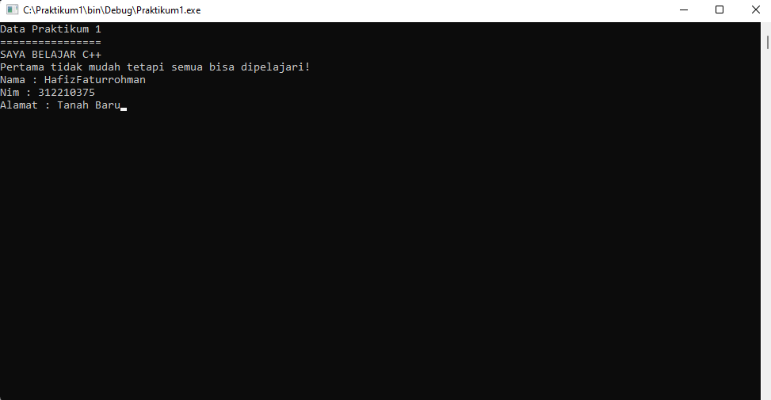

**# Post Test 2**

*#include <iostream>*

*using namespace std;*

*int main()*

*{*

*cout << "Data Praktikan\n";*

*cout << "===================================\n";*

*cout << "Nama = Hafiz Faturrohman\n";*

*cout << "NIM = 312210375\n";*

*cout << "Alamat = Tanah Baru\n";*

*cout << "===================================\n";*

*float luas, keliling, r;*

*cout << "Masukan jari-jari = ";*

*cin >> r;*

*luas = 3.14 * r * r;*

*keliling = 2 * 3.14 * r;*

*cout << "Luas = " << luas <<endl;*

*cout << "Keliling = " << keliling <<endl;*

*return 0;*

*}*

Screenshot Program

